Online Supplemental Information

Appendix S1: Summary of weighted correlation approaches
The community-weighted means (CWMc) used for correlations (Lavorel et al. 2008) are identical to the community-weighted means used for regression (CWMr), although p-values are obtained using permutation tests.
The weighted correlation approaches vary in how the abundances of species within sites are weighted. CWMc (like CWMr) weights the trait values for species within a site by the abundance of the species within the site, and the resulting site-specific trait values are correlated with the environmental values among sites. For the weighted community-weighted means, wCWMc, there is an additional step of weighting trait values per species by the total abundance of that species across all sites; these weighted values are then standardized to have mean zero and variance one, and are used in the same way as the unweighted values used to calculate CWMc. These weightings make all species contribute in proportion to their abundance in the calculation of wCWMc. Species niche centroid correlations (SNCc) are similar to CWMc, but rather than weight the trait values by the relative abundances of species within sites, the environmental values are weighted by the abundances of species within sites, and these weighted values are correlated with trait values (Cavender-Bares, Kitajima & Bazzaz 2004). The weighted wSNCc are similar to SNCc, but there is an initial step of weighting the environmental value of each site by the total abundance of species within the site to make each site contribute equally in the calculation of wSNCc.
Fourth-corner correlations (FCCc) take the same initial steps as wCWMc and wSNCc by weighting the trait values per species by the total abundances of species, and the environment value per site by the total abundance of species at that site. These weighted trait and environmental values are then correlated, with the correlations weighted by the number of individuals in each species-site combination (Dray & Legendre 2008). Specifically,
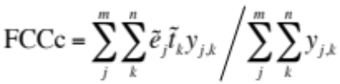 (3)
where y_{j,k} is the number of individuals of species k in site j, and 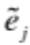 and are the environment value for each site j and trait value for each species k that are weighted by the abundance of individuals in each site and species, respectively, and then standardized to have mean zero and variance one. This formulation only gives a value of one if species abundances are perfectly ordered across sites and species; if species abundances are not perfectly ordered, the value never reaches one for any distribution of trait values among species or environment values among sites. Therefore, Peres-Neto et al. (2017) propose a "Chessel fourth-corner correlation" that standardizes the distribution matrix of values of y_{j,k} so that FCCc can take a value of one when the association between traits and environmental gradient is maximal. The FCCc that we report is the Chessel fourth-corner correlation.

References
Cavender-Bares, J., Kitajima, K. & Bazzaz, F.A. (2004) Multiple trait associations in relation to habitat differentiation among 17 Floridian oak species. Ecological Monographs, 74, 635-662.
Dray, S. & Legendre, P. (2008) Testing the species traits-environment relationships: The fourth-corner problem revisited. Ecology, 89, 3400-3412.
Lavorel, S., Grigulis, K., McIntyre, S., Williams, N.S.G., Garden, D., Dorrough, J., Berman, S., Quetier, F., Thebault, A. & Bonis, A. (2008) Assessing functional diversity in the field - methodology matters! Functional Ecology, 22, 134-147.
Peres-Neto, P.R., Dray, S. & ter Braak, C.J.F. (2017) Linking trait variation to the environment: critical issues with community-weighted mean correlation resolved by the fourth-corner approach. Ecography, 40, 806-816.

Appendix S2. R function for performing parametric bootstrap likelihood ratio tests, bootMer_LRT(), with documentation

bootMer_LRT <- function(mod, formula.r, re.form=NA, nAGQ=0, nboot=2000, verbose=F, data=NA) {

mod.f <- update(mod, nAGQ=nAGQ, control = glmerControl(calc.derivs=F))
mod.r <- update(mod, formula=formula.r, nAGQ=nAGQ, control = glmerControl(calc.derivs=F))
LLR.true <- logLik(mod.f) - logLik(mod.r)

dist <- data.frame(LLR = rep(0,nboot))
sim.data <- model.frame(mod.f)
for(j in 1:nboot){
if(is.na(re.form)){
simY <- simulate(mod.r)
}else{
simY <- simulate(mod.r, re.form=formula(re.form))
}
sim.data[,1] <- simY[,1]
mod.f.boot <- refit(mod.f, newresp=simY)
mod.r.boot <- refit(mod.r, newresp=simY)

dist$LLR[j] <- logLik(mod.f.boot) - logLik(mod.r.boot)
if(verbose==T) show(c(j, LLR.true, dist$LLR[j]))
}
P <- mean(LLR.true < dist$LLR)
return(list(mod.r=mod.r, dist.LLR=dist$LLR, P=P))
}
bootMer_LRT | R Documentation
Parameter Bootstrap Likelihood Ratio Test for fixed-effects terms in merMod {lme4} models over the null hypothesis H0: b=0

Description
bootMer_LRT performs a parametric bootstrap likelihood ratio test comparing full and reduced models.

Usage
bootMer_LRT(mod, formula.r, re.form=NA, nAGQ=0, nboot=2000, verbose=F)

Arguments
mod | full model.
formula.r | glmer formula that excludes the fixed effect for which the p-value is calculated.
re.form | a one-sided formula '~...' giving random effects that are fixed during the bootstrap. See simulate.merMod().
nAGQ | control option for glmer(); nAGQ = 0 (default) will run much faster.
nboot | number of bootstrap simulations.
verbose | prints results to terminal during bootstrapping.

Details
bootMer_LRT refits mod with formula.r using the update function. Note that for binomial models, the data.frame for the data must contain a response variable in the form cbind(successes, failures) identified as a single variable.

Value
mod.r | the model without the fixed effect (i.e., specified by formula.r).
dist.LLR | bootstrap distribution for log likelihood ratios between full and reduced models.
P | bootstrap p-value for the fixed effect.

Author(s)
Anthony R. Ives

References

See Also
bootMer

Examples

## Illustration of bootMer_LRT() with simulated data

inv.logit <- function(x) 1/(1+exp(-x))

size <- 100
nspp <- 10
nsite <- 15

b0 <- -7.0
b1 <- -.38
b2 <- 0
b12 <- .3

sd.obs <- 4.5
sd.intercept.sp <- 0
sd.env.sp <- 0
sd.site <- 0.5769

# binomial example
sim <- data.frame(site = rep(1:nsite, times = nspp), sp = rep(1:nspp, each = nsite), env1 = rep(rnorm(n=nsite), times = nspp), trait1 = rep(rnorm(n = nspp), each = nsite), intercept.sp = rep(rnorm(nspp, sd = sd.intercept.sp), each = nsite), env.sp = rep(rnorm(nspp, sd = sd.env.sp), each = nsite), obs = rnorm(nspp * nsite, sd = sd.obs), site.effect = rep(rnorm(nsite, sd = sd.site), times = nspp), size=100)
sim$y <- (b0 + sim$intercept.sp) + (b1 + sim$env.sp) * sim$env1 + b2 * sim$trait1 + b12 * sim$env1 * sim$trait1 + sim$obs + sim$site.effect
sim$successes <- rbinom(n=nspp*nsite, prob=inv.logit(sim$y), size=size)
sim$Y <- cbind(sim$successes, sim$size – sim$successes)

mod <- glmer(Y ~ env1 * trait1 + (1 + env1 | sp) + (1 | site) + (1 | obs), data = sim, family = "binomial", control = glmerControl(calc.derivs=F), nAGQ = 0)
formula.r <- Y ~ env1 + trait1 + (1 + env1 | sp) + (1 | obs)

b <- bootMer_LRT(mod, formula.r=formula0, nAGQ=0, nboot=2000)
b$P
hist(b$dist.LLR)

# Poisson example
sim <- data.frame(site = rep(1:nsite, times = nspp), sp = rep(1:nspp, each = nsite), env1 = rep(rnorm(n=nsite), times = nspp), trait1 = rep(rnorm(n = nspp), each = nsite), intercept.sp = rep(rnorm(nspp, sd = sd.intercept.sp), each = nsite), env.sp = rep(rnorm(nspp, sd = sd.env.sp), each = nsite), obs = rnorm(nspp * nsite, sd = sd.obs), site.effect = rep(rnorm(nsite, sd = sd.site), times = nspp), size=100)
sim$y <- (b0 + sim$intercept.sp) + (b1 + sim$env.sp) * sim$env1 + b2 * sim$trait1 + b12 * sim$env1 * sim$trait1 + sim$obs + sim$site.effect
sim$Y <- rpois(n=nspp*nsite, lambda=exp(sim$y))

mod <- glmer(Y ~ env1 * trait1 + (1 + env1 | sp) + (1 | site) + (1 | obs), data = sim, family = "poisson", control = glmerControl(calc.derivs=F), nAGQ = 0)
formula.r <- Y ~ env1 + trait1 + (1 + env1 | sp) + (1 | obs)

b <- bootMer_LRT(mod, formula.r=formula.r, re.form = '~(1 + env1 | sp)', nAGQ=0, nboot=2000)
b$P
hist(b$dist.LLR)

Appendix S3. Code used to analyze the Siskiyou Mountain dataset using MLM2(Wald), MLM2(boot), MLM2(boot.sp), and MLM2(glm)

library(lme4)
library(mvabund)

source("Miller_bootMer_LRT_17Oct18.R")
load("Miller_data_23Aug18.Rdata")

######################################################
# 1. Model-based data analyses
######################################################

######################################################
# MLM1(Wald)
mod <- glmer(value ~ env + env:trait + (1 + env|species) + (1 | obs), family = "binomial", control=glmerControl(calc.derivs=F), nAGQ = 0, data=dat)
summary(mod)
# Generalized linear mixed model fit by maximum likelihood (Adaptive Gauss-Hermite Quadrature, nAGQ = 0) ['glmerMod']
# Family: binomial ( logit )
# Formula: value ~ env + env:trait + (1 + env | species) + (1 | obs)
# Data: dat
# Control: glmerControl(calc.derivs = F)

# AIC BIC logLik deviance df.resid
# 6407.7 6451.5 -3196.8 6393.7 3893

# Scaled residuals:
# Min 1Q Median 3Q Max
# -0.86811 -0.21522 -0.14802 -0.07662 0.85125

# Random effects:
# Groups Name Variance Std.Dev. Corr
# obs (Intercept) 6.747 2.5975
# species (Intercept) 8.343 2.8884
# env 0.660 0.8124 0.37
# Number of obs: 3900, groups: obs, 3900; species, 75

# Fixed effects:
# Estimate Std. Error z value Pr(>|z|)
# (Intercept) -7.36493 0.35185 -20.932 < 2e-16 ***
# env -0.69932 0.13868 -5.043 4.59e-07 ***
# env:trait 0.08954 0.12493 0.717 0.474
# ---
# Signif. codes: 0 ‘***’ 0.001 ‘**’ 0.01 ‘*’ 0.05 ‘.’ 0.1 ‘ ’ 1

# Correlation of Fixed Effects:
# (Intr) env
# env 0.352
# env:trait -0.054 -0.196

######################################################
# MLM2(Wald)
mod <- glmer(value ~ env * trait + (1 + env|species) + (1 | site) + (1 | obs), family = "binomial", control=glmerControl(calc.derivs=F), nAGQ = 0, data=dat)
summary(mod)
# Generalized linear mixed model fit by maximum likelihood (Adaptive Gauss-Hermite Quadrature, nAGQ = 0) ['glmerMod']
# Family: binomial ( logit )
# Formula: value ~ env * trait + (1 + env | species) + (1 | site) + (1 | obs)
# Data: dat
# Control: glmerControl(calc.derivs = F)

# AIC BIC logLik deviance df.resid
# 6345.6 6402.0 -3163.8 6327.6 3891

# Scaled residuals:
# Min 1Q Median 3Q Max
# -0.91246 -0.22129 -0.13928 -0.07223 0.93149

# Random effects:
# Groups Name Variance Std.Dev. Corr
# obs (Intercept) 6.3709 2.5241
# species (Intercept) 6.2333 2.4967
# env 0.6249 0.7905 0.30
# site (Intercept) 0.5395 0.7345
# Number of obs: 3900, groups: obs, 3900; species, 75; site, 52

# Fixed effects:
# Estimate Std. Error z value Pr(>|z|)
# (Intercept) -7.4375 0.3271 -22.741 < 2e-16 ***
# env -0.6942 0.1732 -4.009 6.1e-05 ***
# trait 1.0833 0.3083 3.513 0.000443 ***
# env:trait 0.2263 0.1328 1.704 0.088457 .
# ---
# Signif. codes: 0 ‘***’ 0.001 ‘**’ 0.01 ‘*’ 0.05 ‘.’ 0.1 ‘ ’ 1

# Correlation of Fixed Effects:
# (Intr) env trait
# env 0.244
# trait -0.058 -0.071
# env:trait -0.085 -0.205 0.314

######################################################
# MLM2(boot)
boot <- bootMer_LRT(mod, formula.r='value ~ env + trait + (1 + env|species) + (1 | site) + (1 | obs)')
boot$P
# [1] 0.0125
summary(boot$mod.r)

# Generalized linear mixed model fit by maximum likelihood (Adaptive Gauss-Hermite Quadrature, nAGQ = 0) ['glmerMod']
# Family: binomial ( logit )
# Formula: value ~ env + trait + (1 + env | species) + (1 | site) + (1 | obs)
# Data: dat
# Control: glmerControl(calc.derivs = F)

# AIC BIC logLik deviance df.resid
# 6349.9 6400.0 -3166.9 6333.9 3892

# Scaled residuals:
# Min 1Q Median 3Q Max
# -0.91623 -0.21880 -0.13861 -0.07642 0.91471

# Random effects:
# Groups Name Variance Std.Dev. Corr
# obs (Intercept) 6.3737 2.5246
# species (Intercept) 6.2953 2.5090
# env 0.7297 0.8542 0.30
# site (Intercept) 0.5395 0.7345
# Number of obs: 3900, groups: obs, 3900; species, 75; site, 52

# Fixed effects:
# Estimate Std. Error z value Pr(>|z|)
# (Intercept) -7.4081 0.3266 -22.679 < 2e-16 ***
# env -0.6469 0.1736 -3.728 0.000193 ***
# trait 0.9225 0.2932 3.147 0.001651 **
# ---
# Signif. codes: 0 ‘***’ 0.001 ‘**’ 0.01 ‘*’ 0.05 ‘.’ 0.1 ‘ ’ 1

# Correlation of Fixed Effects:
# (Intr) env
# env 0.238
# trait -0.031 0.002

######################################################
# MLM2(boot.sp)
boot <- bootMer_LRT(mod, formula.r='value ~ env + trait + (1 + env|species) + (1 | site) + (1 | obs)', re.form='~(1 + env|species)')
boot$P
# [1] 0.124
summary(boot$mod.r)
# Generalized linear mixed model fit by maximum likelihood (Adaptive Gauss-Hermite Quadrature, nAGQ = 0) ['glmerMod']
# Family: binomial ( logit )
# Formula: value ~ env + trait + (1 + env | species) + (1 | site) + (1 | obs)
# Data: dat
# Control: glmerControl(calc.derivs = F)

# AIC BIC logLik deviance df.resid
# 6349.9 6400.0 -3166.9 6333.9 3892

# Scaled residuals:
# Min 1Q Median 3Q Max
# -0.91623 -0.21880 -0.13861 -0.07642 0.91471

# Random effects:
# Groups Name Variance Std.Dev. Corr
# obs (Intercept) 6.3737 2.5246
# species (Intercept) 6.2953 2.5090
# env 0.7297 0.8542 0.30
# site (Intercept) 0.5395 0.7345
# Number of obs: 3900, groups: obs, 3900; species, 75; site, 52

# Fixed effects:
# Estimate Std. Error z value Pr(>|z|)
# (Intercept) -7.4081 0.3266 -22.679 < 2e-16 ***
# env -0.6469 0.1736 -3.728 0.000193 ***
# trait 0.9225 0.2932 3.147 0.001651 **
# ---
# Signif. codes: 0 ‘***’ 0.001 ‘**’ 0.01 ‘*’ 0.05 ‘.’ 0.1 ‘ ’ 1

# Correlation of Fixed Effects:
# (Intr) env
# env 0.238
# trait -0.031 0.002

######################################################
# MLM2(glm)

nspp <- nlevels(dat$species)
nsites <- nlevels(dat$site)
Ymat <- matrix(dat$Y, ncol=nsites, nrow=nspp, byrow = T)
LL <- t(Ymat)

RR <- dat[dat$species == levels(dat$species)[1], c("site","env")]
QQ <- dat[dat$site == levels(dat$site)[1], c("species", "trait")]

ft <- traitglm(L=LL, R=RR, Q=QQ, family="binomial", K=100, formula = ~env + trait + env:trait + species + env:species + site, method = "manyglm", composition = FALSE, col.intercepts = FALSE)
ft.r <- traitglm(L=LL, R=RR, Q=QQ, family="binomial", K=100, formula = ~env + trait + species + env:species + site, method = "manyglm", composition = FALSE, col.intercepts = FALSE)

z.traitglm <- anova.traitglm(ft, ft.r, nBoot=1000)
z.traitglm

# Analysis of Deviance Table

# Model 1: ~env + trait + env:trait + species + env:species + site
# Model 2: ~env + trait + species + env:species + site

# Multivariate test:
# Res.Df Df.diff Dev Pr(>Dev)
# Model 1 3700
# Model 2 3700 0 0 0.273
# Arguments: P-value calculated using 1000 resampling iterations via PIT-trap block resampling (to account for correlation in testing).

######################################################
# 2. Diagnostics for MLM2
######################################################

######################################################
# MLM2 plots of random effects (Figure S1)
mod <- glmer(value ~ env*trait + (1 + env|species) + (1 | site) + (1 | obs), family = "binomial", control=glmerControl(calc.derivs=F), nAGQ = 0, data=dat)

library(ggplot2)
library(dplyr)
library(viridis)

dat$value <- dat$value[,1]
a <- dat %>%
# create a categorical trait value for plotting
mutate(CN_cut = cut(trait, breaks = 6)) %>%
ggplot(aes(x = env, y = Y/100, colour = trait, fill = trait, group = species)) +
geom_point(pch = 21, colour = "black") +
facet_wrap(~CN_cut, nrow = 1) + labs(x="Topographic moisture gradient", y="Probability of occurrence", fill="C:N") +
stat_smooth(method = "glm", se = FALSE, method.args = list(family = "binomial")) +
guides(colour = FALSE) +
scale_color_viridis()+
scale_fill_viridis() +
coord_trans(y = "sqrt") +
labs(title = "Topographic moisture gradient interaction with C:N")

show(a)

######################################################
# MLM2 plots of residuals (Figure 2)

nspp <- nlevels(dat$species)
nsites <- nlevels(dat$site)

dat$resid <- as.matrix(ranef(mod)$obs)
X <- matrix(dat$resid, nrow=nsites, ncol=nspp, byrow=F)
rownames(X) <- unique(dat$site)
colnames(X) <- levels(dat$species)

# species correlations
corrs.sp <- cor(X, method="kendall")
for(i in 1:nspp) corrs.sp[i,i] <- NA

# site correlations
corrs.site <- cor(t(X), method="kendall")
for(i in 1:nsites) corrs.site[i,i] <- NA

x.sp <- matrix(corrs.sp, ncol=1)
x.site <- matrix(corrs.site, ncol=1)
x.sp <- x.sp[!is.na(x.sp)]
x.site <- x.site[!is.na(x.site)]

# Kolmogorov-Smirnov test for greater-than-expected correlations
ppearson <- function(r) pt(r*((nsites - 2)/(1 - r^2))^.5, df=length(x.sp))
ks.test(unique(x.sp), "ppearson")

# pearson r distribution
dpearson <- function(r, n) {
p <- ((1-r^2)^((n-4)/2))/beta(a = 1/2, b = (n-2)/2)
return(p)
}

# Figure 2 for Data
par(mfrow=c(2,2), mai=c(1,1,.5,.2))
rr <- .01*(-100:100)
plot(rr, dpearson(rr, nsites), typ="l", col="red", xlab="Correlation coefficients", ylab="Probability", ylim=c(0,4), cex.lab=1.2)
hist(corrs.sp, main="", add=T, probability=T, breaks=.1*(-10:10))
text(-.7,3.5,"Species", cex=1.2)
mtext(side=3, "Data", adj=1.4, padj=-1, cex=1.2)

plot(rr, dpearson(rr, nspp), typ="l", col="red", xlab="Correlation coefficients", ylab="Probability", ylim=c(0,4), cex.lab=1.2)
hist(corrs.site, main="", add=T, probability=T, breaks=.1*(-10:10))
text(-.7,3.5,"Sites", cex=1.2)

# permute species residuals among sites
for(i in 1:ncol(X)){
X[,i] <- X[sample(1:nrow(X)),i]
}

# species correlations
corrs.sp <- cor(X, method="kendall")
for(i in 1:nspp) corrs.sp[i,i] <- NA

# site correlations
corrs.site <- cor(t(X), method="kendall")
for(i in 1:nsites) corrs.site[i,i] <- NA

x.sp <- matrix(corrs.sp, ncol=1)
x.site <- matrix(corrs.site, ncol=1)
x.sp <- x.sp[!is.na(x.sp)]
x.site <- x.site[!is.na(x.site)]

# Kolmogorov-Smirnov test for greater-than-expected correlations
ppearson <- function(r) pt(r*((nsites - 2)/(1 - r^2))^.5, df=length(x.sp))
ks.test(unique(x.sp), "ppearson")

# Figure 2 for randomization of species

plot(rr, dpearson(rr, nsites), typ="l", col="red", xlab="Correlation coefficients", ylab="Probability", ylim=c(0,4), cex.lab=1.2)
#lines(rr, 100*dt(rr*((nsites - 2)/(1 - rr^2))^.5, df=Inf)/sum(dt(rr*((nsites - 2)/(1 - rr^2))^.5, df=Inf)))
hist(x.sp, main="", add=T, probability=T, breaks=.1*(-10:10))
text(-.7,3.5,"Species", cex=1.2)
mtext(side=3, "Randomize species among sites", adj=-4, padj=-1, cex=1.2)

plot(rr, dpearson(rr, nspp), typ="l", col="red", xlab="Correlation coefficients", ylab="Probability", ylim=c(0,4), cex.lab=1.2)
#lines(rr, 100*dt(rr*((nspp - 2)/(1 - rr^2))^.5, df=Inf)/sum(dt(rr*((nspp - 2)/(1 - rr^2))^.5, df=Inf)))
hist(x.site, main="", add=T, probability=T, breaks=.1*(-10:10))
text(-.7,3.5,"Sites", cex=1.2)

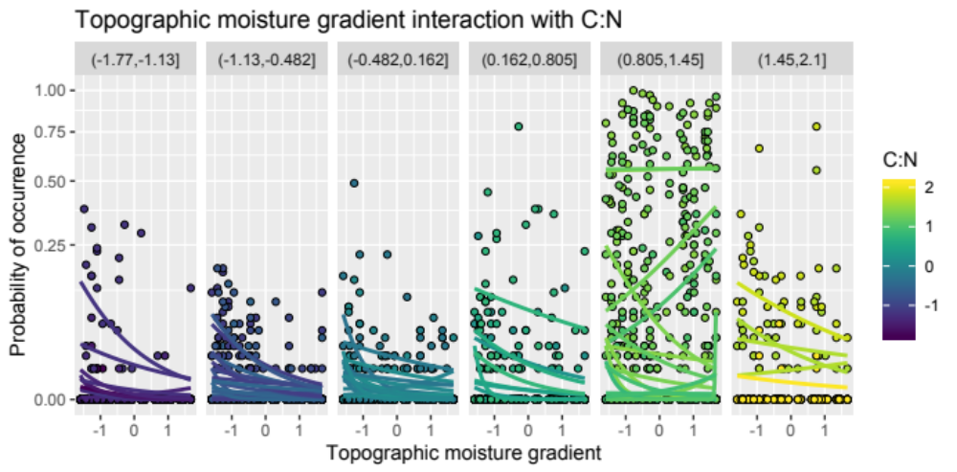
Figure S1. Visualizations of data used in our analyses, showing how the functional trait interacts with the topographic moisture gradient to influence species abundances.

Appendix S4. Explanation for the low power of the Wald test in MLM2, MLM2(Wald)
In simulations (i) and (ii), MLM2(Wald) had low power, but this was corrected by MLM2(boot). The source of low power of MLM2(Wald) is bias in the estimate of β₁₂. To demonstrate this, we simulated 2000 datasets using MLM2 with parameter values estimated from the data, specifically with β₁₂ = 0.23. The mean of the estimates of β₁₂ from MLM2 was 0.15, indicating downwards bias. At the same time, the distribution of the estimates matched the standard error from the Wald approximation used to calculate the p-values in MLM2. In other words, the calculation of the p-values in MLM2(Wald) was based on the correct standard error of the estimates of β₁₂, but they did not account for the downward bias in the estimates of the mean. In contrast, our bootstrap on the null hypothesis that β₁₂ = 0 accounts for the bias. Further exploration of the model showed that the bias is caused by the observation-level variance term e_{i} in equation (1) that accounts for greater-than-binomial variance in the abundance of species in sites. When data were simulated in which there is no observation-level variance (σ²_{e} = 0), the bias in the estimate of β₁₂ disappeared. Furthermore, in models having the same form as MLM2 but built for continuous data, or for binary data of presence/absence of species among sites, estimates of β₁₂ were not biased. Therefore, bootstrapping p-values for β₁₂ to account for bias is only necessary for GLMM analyses in which there is a positive observation-level variance term.

Appendix S5. Explanation for inflated type I errors shown by community weighted mean regressions (CWMr)
Randomization of traits among species should yield random data with respect to the null hypothesis of no trait-environment association, yet CWMr rejected this null hypothesis for the randomization datasets far too often. The poor type I error control of CWMr is caused by the lack of independence of CWMr values among sites that contain the same species. Some species occur in many sites (Fig. S2), and therefore the sites where they occur are more likely to have the same CWMr values. This is exacerbated by a few species having very high mean abundances, and these species will contribute more heavily to the CWMr values (Fig. S2). From the randomization datasets, we calculated the correlation among CWMr values between sites. For randomization of traits among species, the correlations of CWMr were predominantly positive and increased for pairs of sites that shared a greater proportion of their species, indicating that the non-independence is driven by sites sharing the same species. In contrast, for randomization of environment values among sites, the correlations were on average zero and were never strongly positive or negative. This independence of CWMr values under the environmental randomizations explains the correct type I error control of CWMr.
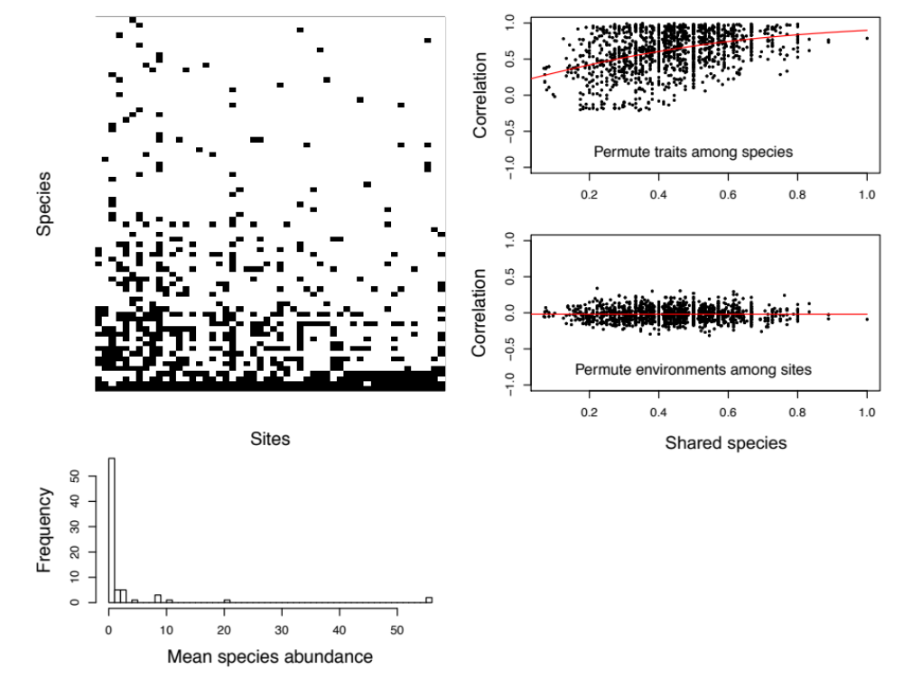

Figure S2. Identifying the cause for the inflated type I error rates of CWMr. The top left panel gives the presence of species among sites (black), with sites sorted by increasing TMG (environmental gradient) and species sorted by the number of sites in which they occur. The lower left panel gives the frequency distribution of mean species abundances. The panels on the right give, for each of the randomizations, the relationship between the pairwise correlation between CWM values for each site and the proportion of shared species between the sites. The correlation in CWM values was calculated from 100 randomizations, and the proportion of shared species was 2*(number of species shared by sites i and j)/((number of species in site i) + (number of species in site j)). The red lines give the function 2/(1 + exp(a + b*x)) fitted with least squares. For the randomization of environmental values among sites, site identity was based on the environmental values in sites, so the randomization moved species and their traits among sites. The high correlations of CWMs when traits are randomized among species (top-right panel) show the non-independence of CWM values among sites; this non-independence is worse between sites that share more species.

Appendix S6. Cases in which the weighted correlation tests have inflated type I errors
Throughout the main text, we modeled our simulation studies on the plant community data from the Siskiyou Mountains. Although the weighted correlation methods with the double permutation test had good type I error control in these simulations, it is possible to generate realistic situations in which they have inflated type I errors. Here, we consider the case in which both trait and the environmental variables have main effects on species abundances, but there is no interaction between their effects. Thus, in this situation there is no association between the effects of trait and environment.
We started with the parameter values from MLM2 under scenario (iv), which is the best-fitting model to the data in the absence of a trait-by-environment interaction term (β₁₂ = 0). The parameterization used for simulation (iv) in figure 1 had large random effects; in particular, the variances of the random effects for observations, species intercepts, the species-specific response to the environmental variable TMG, and sites were 6.76, 6.25, 0.722, and 0.539. To emphasize the fixed effects for trait and environmental variables, we reduced these variances to 1, 1, 0.01, and 0.01. We then considered four combinations for the main effects of trait and environment (β₁, β₂): (0, 0), (2, 0), (2, 2), and (2, –2). These slopes are greater than those estimated from the data, which were β₁ = –0.67 and β₂ = 0.90. We selected these parameter values to illustrate situations where the weighted correlations give inflated type I errors. Nonetheless, the simulated data were not unrealistic, as illustrated by an example simulation in figure S3.

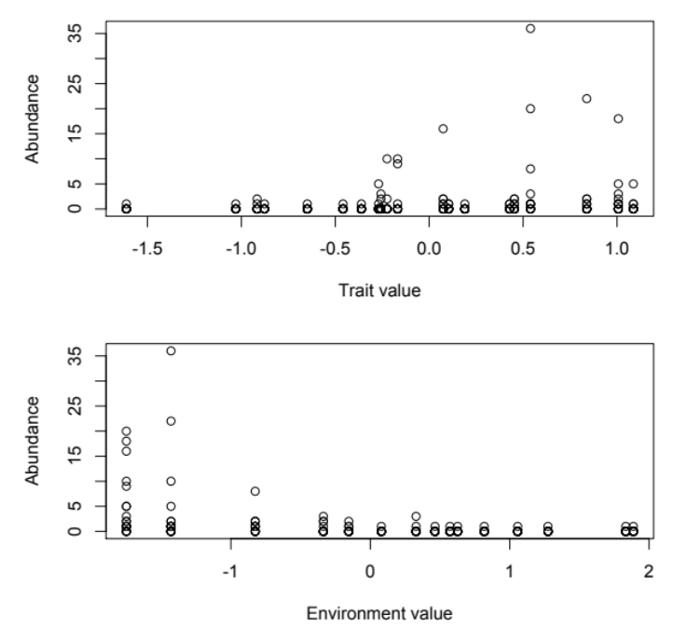
Figure S3. Example simulation for the case in which β₁ = 2 and β₂ = –2, with additional parameter values α = –7.3, β₁₂ = 0, σ²_{e} = 1, σ²_{a} = 1, σ²_{c} = 0.01, and σ²_{b} = 0.01 (equations 1 and 2).

For this collection of simulation scenarios, the weighted correlations showed inflated type I errors when the main effects of trait (β₁) and environmental variable (β₂) were both large (Table S1). These scenarios also led to inflated type I errors for MLM2(boot) and MLM2(boot.sp), although the inflation was not as great as for the weighted correlations. These results are explained by considering figure S3 in which β₁ = 2 and β₂ = –2. In this case, population abundances are zero or close to zero for species with low trait values or in sites with high environmental values. Even though there is no trait-by-environment association, the zero or low abundances at low trait values mean that the abundances at high environmental values cannot become even lower. This statistically then appears like a positive trait-by-environment association and leads to inflated type 1 errors. Heuristically, this apparent interaction is simply the result of the impossibility of negative abundances.

Table S1. Proportion of simulated datasets for which the null hypothesis H0: β₁₂ = 0 was rejected at the 0.05 significance level under simulations with β₁₂ = 0, α = –7.3, σ²_{e} = 1, σ²_{a} = 1, σ²_{c} = 0.01, σ²_{b} = 0.01, and values of β₁ and β₂ given in the table.
β₁ | β₂ | CWMc | wCWMc | SNCc | wSNCc | FCCc | MLM2(boot) | MLM2(boot.sp)
0 | 0 | 0.023 | 0.028 | 0.029 | 0.022 | 0.021 | 0.032 | 0.038
2 | 0 | 0.035 | 0.024 | 0.019 | 0.021 | 0.016 | 0.055 | 0.047
2 | 2 | 0.115 | 0.135 | 0.151 | 0.127 | 0.15 | 0.09 | 0.084
2 | –2 | 0.116 | 0.142 | 0.165 | 0.146 | 0.14 | 0.093 | 0.094

The inflated type I errors shown by the weighted correlations imply that care should be taken when there are visible main effects of trait and environmental values on species abundances. For a given dataset, however, it will be unclear how severe the inflated type I errors might be. Therefore, we recommend fitting MLM2 to the data and performing a simulation study such as the one we performed above.

Appendix S7. Transforming abundances for weighted correlations
When this article was posted for online early viewing by Methods in Ecology and Evolution, Pedro R. Peres-Neto (Department of Biology, Concordia University) generously made an interesting suggestion: we should consider either a square-root transform of abundance data before performing the weighted correlations, or perform the weighted correlations on presence/absence data. Following his suggestion, we repeated the simulations from figure 1 for the weighted correlations using a square-root transform and presence/absence data (Fig. S4). These two transformations increased the power of all of the weighted correlation methods, and especially the fourth-corner weighted correlation which had power roughly equal that of MLM2(boot) (compare Fig. S4 with Fig. 1).

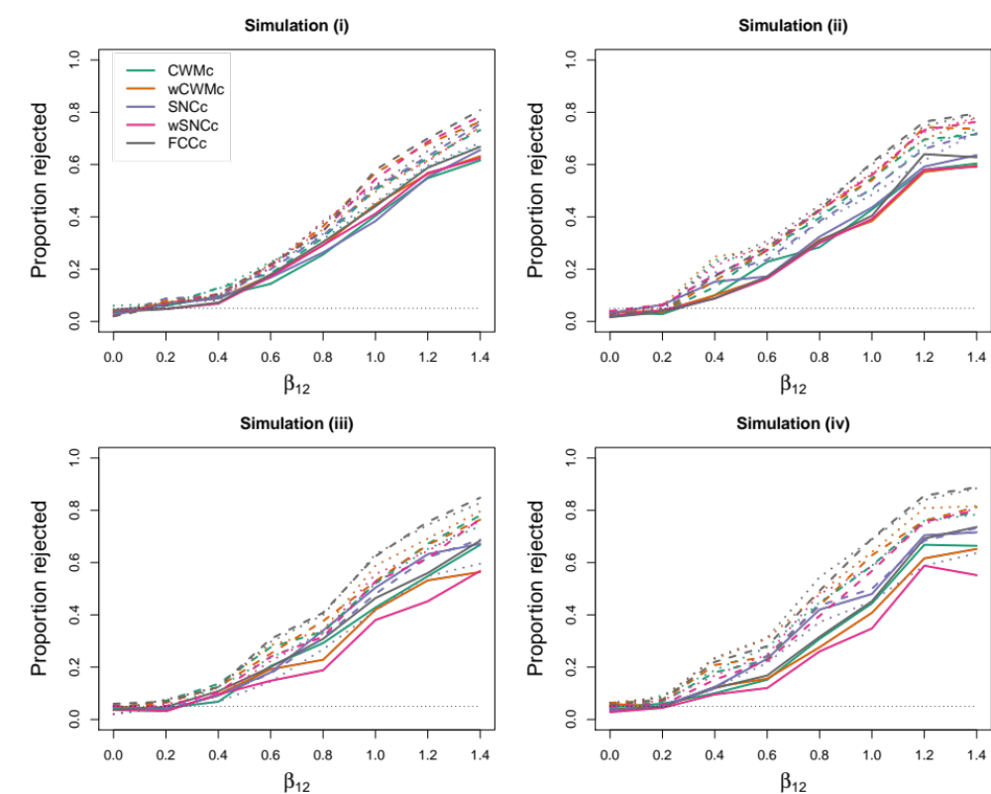
Figure S4. Results from simulation studies using MLM2 under scenarios: (i) β₂ = 0, (ii) σ_{a} = σ_{c} = 0, (iii) β₂ = σ_{a} = σ_{c} = 0, and (iv) β₂ ≠ 0, σ_{a} ≠ 0, and σ_{c} ≠ 0. MLM2 was first fit to the dataset under the four scenarios with β₁₂ = 0. The fitted MLM2 was then used to simulate 250 datasets at β₁₂ = 0, 0.2, ..., 1.4 for 20 species distributed among 15 sites. Results for CWMc, wCWMc, SNCc, wSNCc, and FCCc are show, with solid lines giving results for untransformed abundances, dashed lines for square-root transformed abundances, and dotted lines for presence/absence data.

Nonetheless, transforming the abundance data led to seriously inflated type I errors when tested under the scenario in Appendix 6 in which there were large main effects of trait and environmental values on species abundances (Table S2). For example, FCCc rejecting the (correct) null hypothesis in 59% and 86% of the simulated datasets after a square-root transform and converting to present/absence data, respectively. Furthermore, when the true value of β₁₂ was –0.8, the power was very low in comparison to MLM2(boot) and MLM2(boot.sp) for transformed data (as well as untransformed abundances). These results suggest that more work will have to be performed to investigate data transforms before they can be recommended.

Table S2. Proportion of simulated datasets for which the null hypothesis H0: β₁₂ = 0 was rejected at the 0.05 significance level under simulations with β₁ = –2 and β₂ = 2, and values of β₁₂ given in the table. Data for the weighted correlations were either untransformed, square-root transformed, or turned into presence/absence data. Other parameter values are α = –7.3, σ²_{e} = 1, σ²_{a} = 1, σ²_{c} = 0.01, and σ²_{b} = 0.01.
β₁₂ | transform | CWMc | wCWMc | SNCc | wSNCc | FCCc | MLM2(boot) | MLM2(boot.sp)
0 | none | 0.120 | 0.160 | 0.162 | 0.144 | 0.149 | 0.100 | 0.087
0 | square-root | 0.326 | 0.548 | 0.384 | 0.521 | 0.591
0 | presence | 0.556 | 0.789 | 0.603 | 0.765 | 0.858
-0.8 | none | 0.085 | 0.070 | 0.084 | 0.076 | 0.123 | 0.679 | 0.518
-0.8 | square-root | 0.053 | 0.076 | 0.064 | 0.084 | 0.136
-0.8 | presence | 0.114 | 0.249 | 0.123 | 0.224 | 0.341
0.6 | none | 0.546 | 0.550 | 0.584 | 0.596 | 0.600 | 0.806 | 0.644
0.6 | square-root | 0.709 | 0.878 | 0.724 | 0.882 | 0.913
0.6 | presence | 0.779 | 0.926 | 0.791 | 0.910 | 0.957

